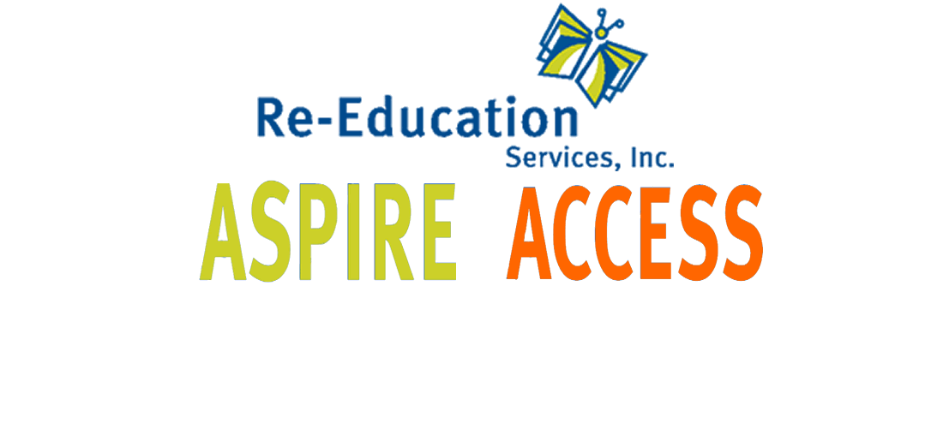

Strategies for a Safe & Responsible Return
2020-2021 School Year
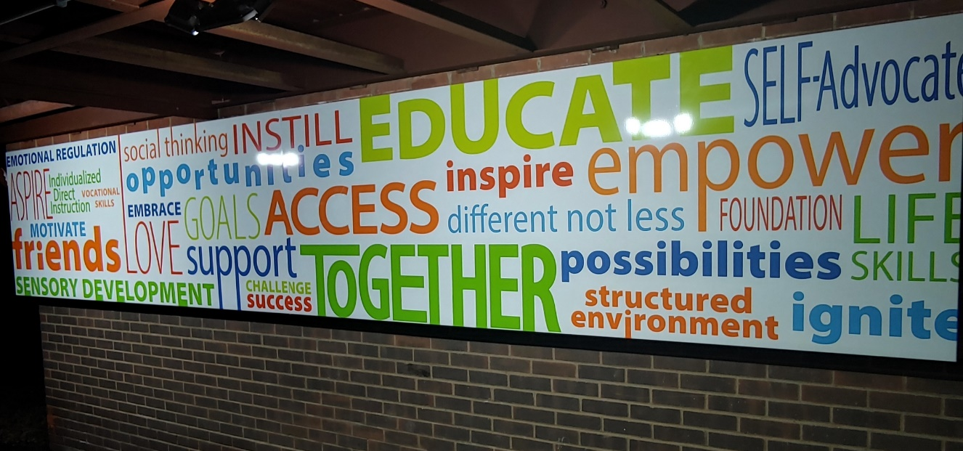

Dear Re-Education Services Families,

Thank you for your continued trust and support for our programs. We know the past several months have been very challenging for you and your families. We are looking forward to returning back to school on September 2nd with many well thought out “new” safety plans and procedures. We feel it is important to bring our students back to our normal school schedule of Monday -Friday and continue with our full school day hours (7:50am – 2:15pm).
Re-Education Services understands the importance for your student to attend in-person education. The unique needs of each of our students are best addressed in the school setting. Re-Education continues to offer small class sizes, individualized instruction, limited transitions, limited common area usage, eye to eye supervision and one to one direction to encourage hand washing and protective mask wearing.
In preparation for opening we have been researching and developing best practices by taking in consideration the Health and Safety of our students and staff. We continue to follow CDC guidelines along with our local health department and ODE (Ohio Department of Education) recommendations.
We have created a detailed plan in this booklet to provide a safe environment for our students and staff. We will be implementing procedures to follow all of the guidelines that you see in the booklet.
We look forward to seeing all of our students again and working with each of you in this “new” way of learning.

Sincerely,

Fredrick A. Frisco
President

#TOGETHER

REOPENING CONSIDERATIONS

HEALTH & SAFETY - Personal Protective Equipment, health monitoring, safety protocols
ACADEMICS - Student engagement & options for learning models
ENGAGEMENT - Communication, coordination, equity, & access
SOCIAL EMOTIONAL - Attention to student & staff well-being
OPERATIONS - General guidelines, transportation, & visitors
HUMAN RESOURCES - Staffing, recruitment, & employee relations
ADMINISTRATION - Safe reopening of school buildings & grounds
ACADEMICS - Student engagement & options for learning models
ENGAGEMENT - Communication, coordination, equity, & access

REOPENING PLAN RECOMMENDATIONS
Re-Education Services, Inc. Administration recommendations are tentative and can be influenced by a number of factors including:

- Changing health and safety guidelines
- Updated guidance from state and county officials
- Resources available and feasibility of safely reopening schools
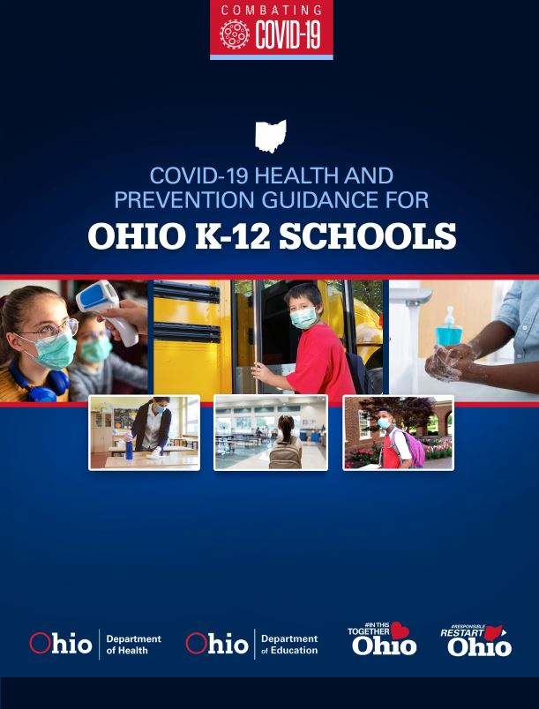

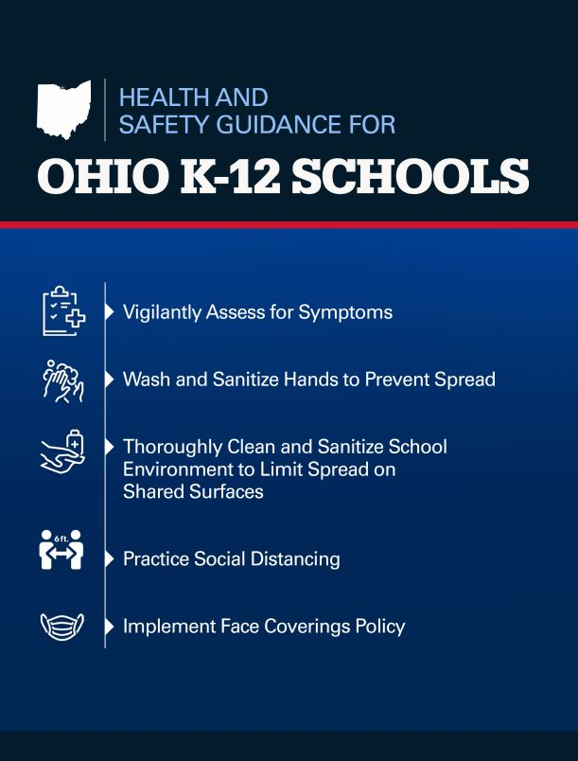

GUIDING PRINCIPLES

EDUCATIONAL – LEARNING  Provide in-person instruction for all attending students as much as possible with high-risk students & families receiving priority placement.  Be prepared to return to remote learning at any time due to COVID-19. | HEALTH – SAFETY  We will continue to follow guidance from ODH, ODE, OHSAA and the Local County Public Health Department. | SOCIAL – EMOTIONAL  Support social learning and interaction to the fullest extent while practiving social distancing. | OPERATIONS  Continued eye to eye supervision to mitigate exposure risk  Small class sizes to keep social distancing  Limit school day transitions  In person instruction to address Social-emotional needs  Limit common area usage  Continue to address individualized needs  All inclusive classrooms limit movement around buildings

STUDENTS IN-PERSON & IN-BUILDINGS WITH SAFETY PROTOCOLS

CLASSROOMS
PARENTS/CAREGIVERS
- Conduct a student wellness check for any COVID symptoms including temperature prior to sending a student to school. Students with temperatures over 100°F should stay home.
- Provide a mask for your student to wear to school and one to keep at school as a spare.

STUDENTS
- Wearing a mask will be required in the classroom.
- Students need to have a spare mask stored in the classroom in the event they forget or soil the mask they wear to school.
- Maintain maximum social distance from peers whenever possible including while eating breakfast or lunch in the classroom.
- All students must sanitize their hands upon entering classrooms.
- All students must wash their hands with soap and water or use hand sanitizer prior to eating any food.
- Breakfast and lunch will be eaten in the classrooms.

STUDENTS IN-PERSON & IN-BUILDINGS WITH SAFETY PROTOCOLS

CLASSROOMS - continued

CLASSROOM TEAM MEMBERS
- Conduct a self-wellness check for any COVID symptoms including temperature prior to arrival at school.
- Wear a mask at all times.
- Ensure classroom setup of desks provides social distancing for students.
- Sanitize classroom areas throughout the school day.
- Supervise designated eating areas to ensure students are properly socially distanced.
- Ensure students maintain social distance whenever possible.
- Provide reminders, issue warnings, contact parents/caregivers.
- Eliminate shared classroom materials.
- Keep the classroom door open to maximize airflow and reduce the number of touches to door handles.

ADMINISTRATION
- Ensure health monitoring protocols are being followed.
- Ensure classrooms are socially distanced.
- Ensure classrooms are disinfected during the school day.
- Ensure cleaning supplies are readily available.

STUDENTS IN-PERSON & IN-BUILDINGS WITH SAFETY PROTOCOLS

SCHOOL ARRIVAL, HALLWAYS, AND COMMON AREAS
PARENTS/CAREGIVERS
- Provide a mask for your child to wear in school.
- Provide your student with a water bottle daily as water fountains will not be available for use.

STUDENTS
- Wearing a mask is required in the hallways and common areas.
- Upon arrival students will maintain social distancing while waiting to go through building check-in.
- While waiting for check-in, student will have their temperatures taken and answer health screening questions.
- Maintain social distancing in hallways and common areas.
- Follow all signage in the hallways and common areas.
- When possible, stay to the right when traveling down hallways and using stairs.

CLASSROOM TEAM MEMBERS
- Wear a mask at all times.
- Sanitize areas after your students have used the area.
- Supervise hallways and common areas to ensure students are reporting immediately to class and not congregating in hallways or common areas.
- Provide reminds, issue warnings, contact parents/caregivers.
- Supervise implementation of locker/cubby use schedule to minimize congestion in hallways or buildings who issue lockers/cubbies.

ADMINISTRATION
- Ensure proper signage is installed in hallways and common areas.
- Ensure supplies are readily available.
- Implement staggered arrival and dismissal times if necessary to maximize social distancing and student safety.

STUDENTS IN-PERSON & IN-BUILDINGS WITH SAFETY PROTOCOLS

DROP OFF, PICK UP, AND VISITORS
PARENTS/CAREGIVERS
- Conduct a student wellness check for any COVID symptoms including temperature prior to sending a student to school. Students with temperatures over 100°F should stay home.
- Provide a mask for your student to wear at all times.
- Limit visits to the school as much as possible.
- Follow posted guidelines and read all signage whenever entering the building.
- Wearing a mask is required when entering the building.
- All visitors to our buildings during the school day will have their temperatures taken by a member of our staff. Visitors with temperatures 100°F or higher will not be permitted to enter the building.
- When dropping off students, call the school office before escorting students to the building entrance. Staff will meet you at the door.
- When picking up students, call the school office and your student will be brought to the door for you to sign out.
- Limit visits to the school as much as possible including visits to drop off forgotten lunches.

STUDENTS
- Wearing a mask is required.
- Maintain maximum social distance from peers whenever possible in hallways, common areas, offices, etc.
- When arriving at school, you will be met at the door and escorted to your classroom upon arrival.
- Upon arrival students will have their temperatures taken and answer health screening questions.

STUDENTS IN-PERSON & IN-BUILDINGS WITH SAFETY PROTOCOLS

DROP OFF, PICK UP, AND VISITORS - continued
CLASSROOM TEAM MEMBERS
- Staff will meet students upon arrival and escort during pick up and complete sign in/sign out log at entrances.
- Ensure students wash/disinfect their hands upon arrival.
- Supervise hallways and common areas to ensure students are reporting immediately to assigned class and not congregating in hallways or common areas.
- Provide reminds, issue warnings, contact parents/caregivers.

ADMINISTRATION
- Ensure health monitoring protocols are followed.
- Ensure adequate supervision is available in bus lots, in parking lots, and in common areas of the building.
- Ensure proper signage is installed in hallways and common areas.
- Ensure cleaning supplies are readily available.
- Provide reminders, issue warnings, contact parents/caregivers.
- Ensure designated doors are propped open at arrival and dismissal.
- Ensure designated doors are closed after arrival and dismissal.
- Eliminate parent and community volunteers to ensure safety and health of students and staff.
- Implement staggered dismissal times if necessary to maximize social distancing and student safety.

STUDENTS IN-PERSON & IN-BUILDINGS WITH SAFETY PROTOCOLS

TRANSPORTATION
PARENTS/CAREGIVERS
- Conduct a student wellness check for any COVID symptoms including temperature prior to sending your student to the van/bus. Students with temperatures over 100°F should stay home.
- Provide a mask for your student.
- Ensure your student is only bringing items necessary for school.

STUDENTS
- Maintain appropriate social distances while walking to and from vans and buses and while entering the building.
- Sit in your assigned seat.
- Wear a mask while riding the bus/van.
- Remain seated, facing forward while riding the bus/van.
- Wait for your seat to be called before exiting the school bus/van.
- All students must sanitize their hands before entering the bus/van.

DRIVERS
- Wear a mask at all times.
- Provide reminders to students of bus/van expectations – assigned seat, wearing masks, seated facing forward, no sharing of items.
- Provide reminders, issue warnings, and report repeated violators to their teacher.
- Ensure bus/van is disinfected following outlined safety protocols.

ADMINISTRATION
- Monitor drop off and dismissal to ensure students do not congregate in groups.
- Provide consequences, including loss of privilege to those who violate the rules.

STUDENTS IN-PERSON & IN-BUILDINGS WITH SAFETY PROTOCOLS

MEETINGS AND CONFERENCES
PARENTS/CAREGIVERS
- Notify the school of your preference to attend meetings in person, via phone, or using a virtual platform.
- In person meetings should follow appropriate social distancing protocols and it is required that a mask be worn at all times.
- Temperature and health screening questions will be completed for all attendees.
- Conduct a personal health screening prior to coming to a school building and do not come if you are running a fever higher than 100°F or showing other symptoms.

STUDENTS
- Participate in meetings as requested by parents/caregivers or school staff.
- Follow social distancing protocols.
- Wearing a mask is required.

CLASSROOM TEAM MEMBERS
- When possible, attend meetings using video technology.
- Masks are required when attending conferences or meetings.

ADMINISTRATION
- Provide parents/caregivers with options for in-person, phone, or video conferencing.
- Ensure social distancing guidelines are followed as much as possible when in-person meetings are held.
- Ensure physical space used for meetings allows for distancing guidelines.
- Ensure the room is sanitized between meetings.

STUDENTS IN-PERSON & IN-BUILDINGS WITH SAFETY PROTOCOLS

HEALTH & WELLNESS
PARENTS/CAREGIVERS
- Conduct a student wellness check for any COVID symptoms including temperature prior to sending a student to school. Students with temperatures over 100°F should stay home.
- Provide a mask for your student to wear while at school and a spare to keep at school.
- Ensure contact information is up to date in the event the school needs to contact home.
- Ensure there are multiple, pre-arranged methods of getting a student home from school should they become ill or exhibit symptoms.

STUDENTS
- Wearing a mask will be required.
- Following social distancing protocols as much as possible when in the office.

CLASSROOM TEAM MEMBERS
- Wear a mask at all times.
- Ensure any areas used are kept clean and sanitized.
- Ensure social distancing protocols are followed whenever possible.
- Isolate students who are showing symptoms to a separate area.
- Ensure any area is disinfected immediately following a student entering who is exhibiting symptoms.

ADMINISTRATION
- Install barriers as needed to protect employees working in the office.
- Ensure proper signage is installed.
- Ensure regular cleaning and disinfecting takes place in the office area.
- Ensure seating areas are properly socially distanced.
- Ensure student isolation area is properly supervised when in use.
- Establish a Quarantine Room for students who are ill and are awaiting their parents.

STUDENTS IN-PERSON & IN-BUILDINGS WITH SAFETY PROTOCOLS

RESTROOMS
PARENTS/CAREGIVERS
- Discuss all safety protocols with child(ren) including proper handwashing techniques.
- Provide a mask for your student to wear while in school.

STUDENTS
- Wearing a mask is required.
- Follow signage in the hallways, common areas and restrooms.
- When possible, stay to the right when traveling down hallways to get to restrooms.
- Maintain social distancing while waiting for the restroom.
- Minimize the touching of surfaces in the restroom.
- Before exiting restroom, wash hands using proper handwashing techniques.

CLASSROOM TEAM MEMBERS
- Assist in supervision of restrooms, hallways, and common areas.
- Provide reminders, issue warnings, contact parents/caregivers.
- Provide supervision of the restrooms to ensure limited numbers of students are in the restrooms at the same time
- Ensure restroom is cleaned/sanitized after students’ use.

ADMINISTRATION
- Ensure proper signage is installed in hallways, common areas and restrooms.
- Ensure cleaning supplies are readily available.
- Ensure reminders, issue warnings, contact parents/caregivers.
- Provide supervision of the restrooms to ensure limited numbers of students are in the restrooms at the same time.
- Implement measures such as closing sinks or urinals when necessary to allow for appropriate social distancing.
- Establish a schedule for restroom breaks.

STUDENTS IN-PERSON & IN-BUILDINGS WITH SAFETY PROTOCOLS

OFFICE
PARENTS/CAREGIVERS
- Conduct a student wellness check for any COVID symptoms including temperature prior to sending a student to school. Students with temperatures over 100°F should stay home.
- Wearing a mask is required.
- In-person office visits should follow appropriate social distancing protocols.
- Temperatures and health screening questions will be completed for all visitors.

STUDENTS
- Wearing a mask will be required.
- Use designated entrances and exits to the office.
- Follow social distancing protocols as much as possible when in the office.
- All students must sanitize their hands upon entering the office.

CLASSROOM TEAM MEMBERS
- Wearing a mask is required at all times.
- Follow social distancing protocols.

OFFICE STAFF
- Monitor and control the amount of people in the office at any one time.
- Ensure social distancing guidelines are followed as much as possible when in-person meetings are held.
- Wearing a mask is required at all times.
ADMINISTRATION
- Eliminate community and parent volunteers to ensure safety of all students.
- Ensure proper signage is installed in the office and leading into the office.
- Ensure regular cleaning and disinfecting takes place in the office area.

STUDENTS IN-PERSON & IN-BUILDINGS WITH SAFETY PROTOCOLS

REMOTE LEARNING (if state or local regulations require a school closure, we would shift into remote learning)
PARENTS/CAREGIVERS
- Monitor student progress on coursework.
- Developing a “school schedule” is recommended to keep routines in place for students while working from home.
- Communicate questions and concerns immediately to staff.

STUDENTS
- Following a regular schedule is recommended to help keep routines in place for students while working from home.
- Communicate questions and concerns immediately to teachers.
- Participate in virtual sessions with teachers as scheduled.
- Watch lessons provided by teachers and complete assignments according to timelines.

CLASSROOM TEAM MEMBERS
- Create interactive lessons that are engaging for students using a variety of strategies.
- Be available for office hours, one session will be available in the morning and one in the afternoon.
- Use school approved platform as the platform for all assignments, links to resources, etc.
- Grade work and collect data in a timely manner and provide feedback to students on assignments.

ADMINISTRATION
- Monitor and assist teachers in the delivery of content for students.
- Implement appropriate grading procedures and work from home guidelines for teachers.

